Lab Report

Date: May 22th , 2026
Team: E1
Team Members
Last name | First name | Email
Rahman | Md Mahbubur | md-mahbubur.rahman@stud.hshl.de
Sakib | Md Naimur Rahaman | md-naimur-rahaman.sakib@stud.hshl.de
Xu | Yongyu | yongyu.xu@stud.hshl.de
Koluacik | Baris | baris.koluacik@stud.hshl.de

Goal
Assemble the vehicle and create the first version of SysML diagrams for your vehicle project.
Discussion
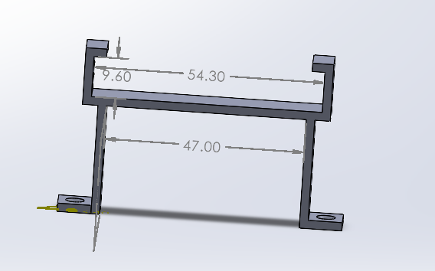
1. After securing the Arduino and motor controller in place, we found that the battery was difficult to remove, so we redesigned the breadboard holder.
Figure 2 latest design of Battery Holder
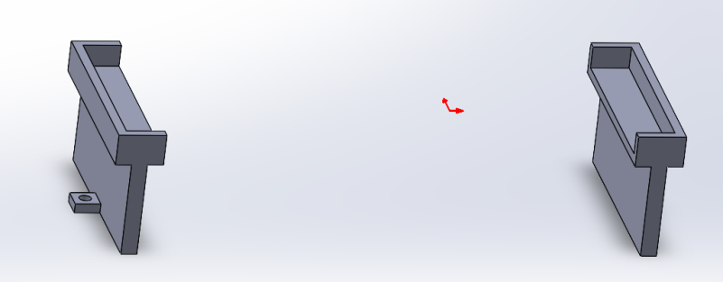
Figure 1 original design of Battery Holder

2. We assembled our vehicle according to the design in SolidWorks.

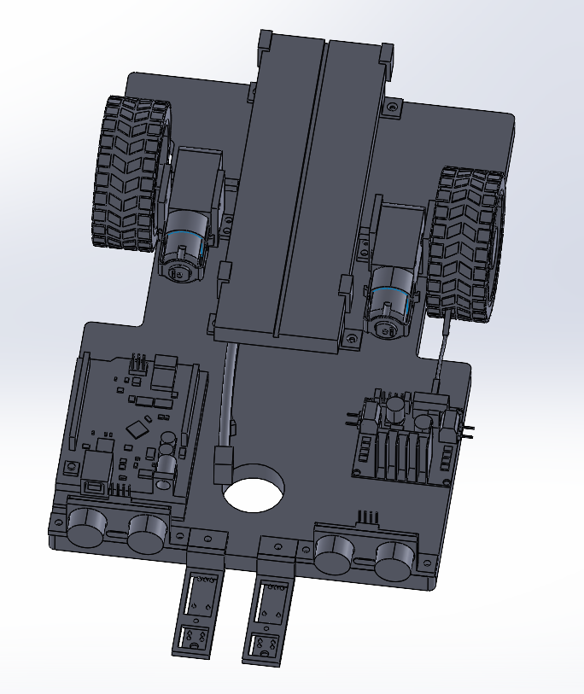
Figure 3 Assembly in Solidworks

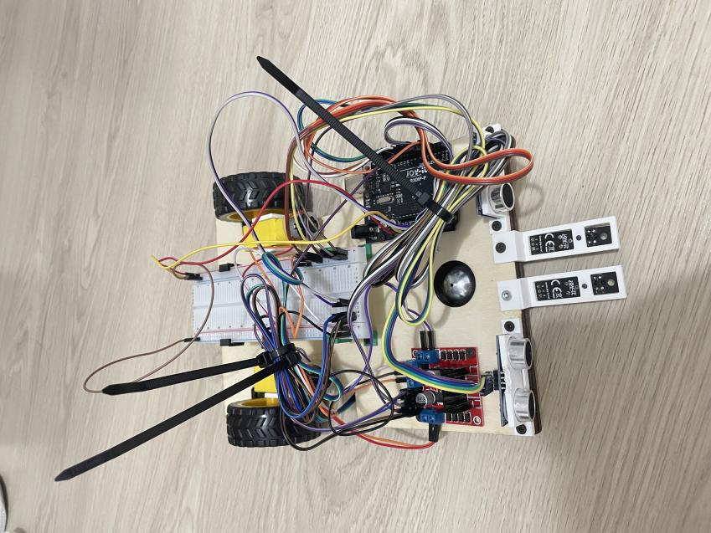

Figure 4 Assembly (Full)

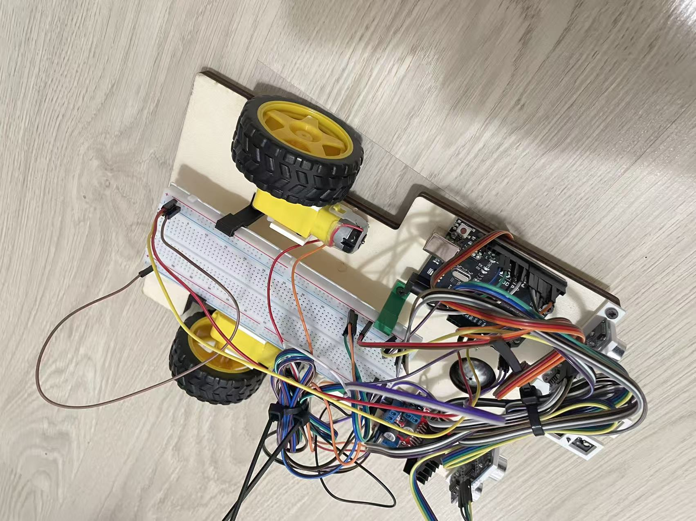
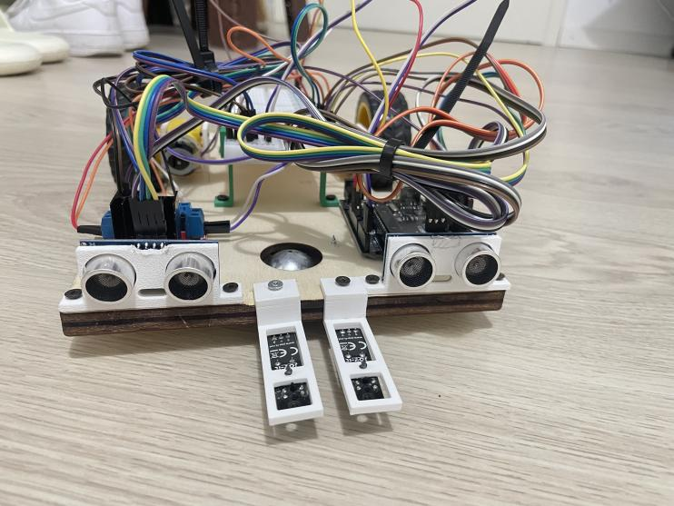

Figure 6 Assembly (Left)

Figure 5 Assembly (Front)

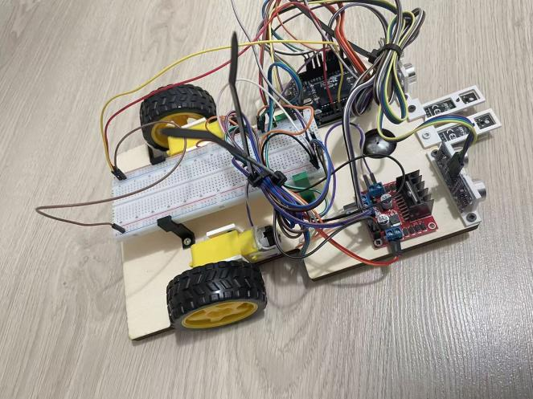

Figure 7 Assembly (Right)

- Designed a wiring diagram in Tinkercad(The codes are not ready).
